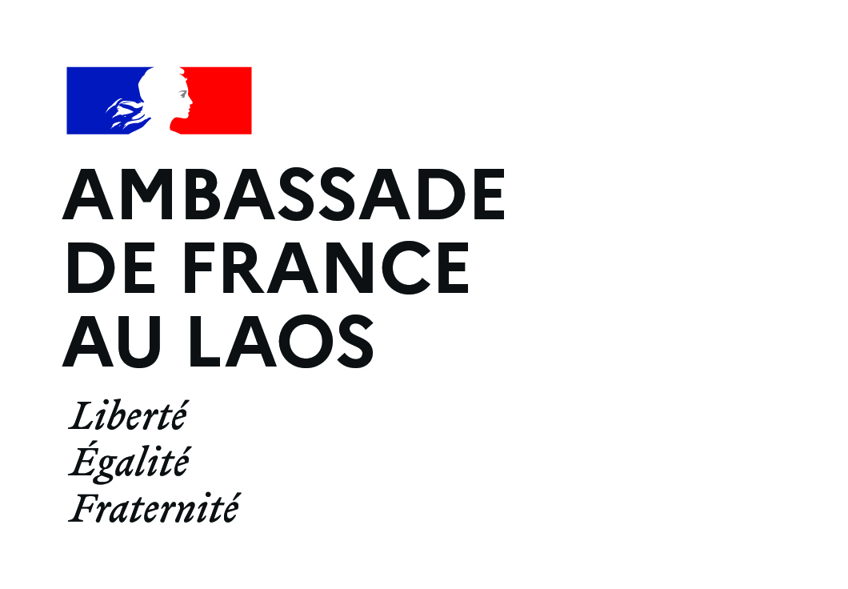
PISCCA 2023
APPLICATION FORM

HOW TO APPLY
- Read the PISCCA call for projects, check whether your organization is eligible and whether your project meets all the eligibility criteria.

- Complete the application form, the document should be typed and not exceed 15 pages.

- In addition to the completed form, join to the application the following documents:
☐ Certification of registration or proof of submission to the Ministry of Home Affairs.
☐ Last two annual reports (if available).
☐ Any other document that the applicant deems useful can be included (e.g. detailed budget in excel format).

Send the complete file (application form in word format and additional documents in PdF) to piscca.vientiane-amba@diplomatie.gouv.fr.

All the documents, including the application form, should be sent in English.
The email must have the subject line “PISCCA 2023 - Name of your organization” and its size must not exceed 10Mb. Deadline to submit proposals: 13/01/2023.

- INFORMATION ON YOUR ORGANIZATION

Some indications have been highlighted in green and italics to help you to fill in the application. Please delete these green indications once the application has been completed.

NAME OF THE ORGANIZATION | Indicate your organization's name
Year of establishment
Type of organization | NPA, Foundation etc.
Director’s name | Mr/Mrs Name
Director’s contact | email, tel / Whatsapp
Website and social media pages (if any)
Office address, tel. and email address
Mission and main goal
Target group(s)
Area of implementation /Province
- INFORMATION ON THE PROJECT

NAME OF THE PROJECT | Indicate the name of your project
Main coordinator name and contact | Mr/Mrs  Email :  Tel. / Whatsapp :
Sector of activity | According to the terms of this call for proposal, what is/are the main sector(s) for the proposed project?
Main goal of the project
Total budget (LAK) | Indicate the total budget of the project
Funding request from PISCCA | Between a minimum of 100M LAK and a maximum of 500M LAK.
Other funding(s) | Mention the amount and other funding source(s).
Duration of the project | Indicate the number of months (12 max)
Where will your project be implemented? | Please provide the name of province(s), district(s) and village(s)
Beneficiaries | Mention an estimated number of targeted beneficiaries and if possible indicate the number or % of women

- DESCRIPTION OF THE PROJECT

This whole section aims to describe the project’s main objectives/goals, the activities and the results expected. Please provide within this section qualitative and quantitative indicators. When possible, gender-sensitive indicators should be outlined. Please remember indicators need to be easily measurable.
  - Issues addressed and project design

Please provide a description of the major issue(s) the organization wishes to address. How the needs were assessed (need assessment survey/visit, focus group, daily analysis, etc.)?
- Problem identification: what are the issues/problems/challenges faced by the target group/communities you work with? What are their needs? Why is it important to address them? Please include statistics/data.
Max. 100 words.

- Please describe how this project has been designed. Did you interact with your target beneficiaries, local government, or any other partner? If that is the case, please describe how you consulted them.
Max. 100 words.

- How will your project address issues/challenges/problems faced by target beneficiaries mentioned above? How will it improve/change their situation?
Max. 100 words.

  - Short description of the project

Max 70 words.

  - Target beneficiaries

Please provide information about the targeted group(s): who and how many beneficiaries? Age, gender, population specific group, etc.
Max. 50 words.

  - Gender approach

How would you rate your project according to Development Assistance Committee (DAC) gender policy marker?
☐ Marker 2 “Principal”: means that gender equality is the main objective of your project and is fundamental is its design and expected results. The project would not have been undertaken without this objective.
☐ Marker 1 “Significant” means that gender equality is an important and deliberate objective, but not the principal reason for undertaking your project, often explained as gender equality being mainstreamed in the project.
☐ Marker 0 “Not targeted” means that your project has been screened against the gender marker but has not been found to target gender equality.

Please precise the gender approach of the project: how are integrated gender concerns in your project? How does your project answer to the specific needs of women and girls, and how does it participate to their empowerment and protection? What strategies will be undertaken to overcome barriers to the inclusion of female beneficiaries?
Max. 70 words.

  - Additional information on project

- Lessons learnt: indicate, if any, what project(s) your organization has already implemented in the same sector and the lessons learned that will enable you to succeed in this new project
Max. 70 words.

- Sustainability: what will be the lasting impacts of your project? Please indicate what will remain after its closure.
Max. 50 words

- Describe the potential risks in the implementation of the project and how you will address them.
Max. 70 words

- LOGFRAME

This section aims to describe the project’s main objectives/goals, the activities and the results expected.

Activity | Expected result(s) | Target indicator | Source of verification/monitoring (reports, minute of meeting, survey etc.)
Objective 1
1.1.
1.2.
1.3.
add rows as necessary
Objective 2
2.1.
2.2
add rows as necessary

- TIMEFRAME

Description of activities | Timeframe (months)
 | 1 | 2 | 3 | 4 | 5 | 6 | 7 | 8 | 9 | 10 | 11 | 12
Objective 1
Activity 1.1 | X | X | X | X | X | X |  | X
Activity 1.2 | X | X | X | X | X
add rows as necessary
Objective 2
Activity 2.1 | X | X | X | X
Activity 2.2 |  |  | X
Activity 2.3 |  |  |  | X | X | X |  | X
add rows as necessary

- BUDGET

Please use these official exchange rates to fill in the budget template: 1 LAK = 0,00005586 € / 1 USD = 0,9647 €
Total project budget (LAK):
Amount of grant requested under the PISCCA (LAK):
Contribution from your organization (LAK):
Co-financing from other donors, specify name(s) of donor(s) and time period (LAK):

Description | Unit | Cost per unit (LAK) | No. of Units | Total budget (LAK) | Total budget (EUR) | PISCCA contribution (LAK) | PISCCA contribution (EUR)
Activities
Activity 1.1
Activity 1.2
add rows as necessary
Activity 2.1
Activity 2.2
add rows as necessary
Human resources/Salaries*
Details
add rows as necessary
Subtotal HR/salaries
Administrative costs
Details
add rows as necessary
Subtotal Administrative costs
subtotal HR + Administrative costs**
Others
Details
add rows as necessary
TOTAL

* This share will take into account the salaries of your organization's employees, please precise their position and % of time dedicated to the project.
If you are working with short term experts or service provider for specific activities, this could be mentioned in activities.
** The subtotal for HR + administration should not exceed 30% of the total project budget.
- PROJECT TEAM & IMPLEMENTING PARTNERS

  - Project team

Name (if already in place) | Position | Email and tel.
 | Project coordinator
add rows as necessary

  - Partners

Name of the partner | Type of organization (government at national or local level, NGO, etc.) | Role in the project and modalities of the partnership
add rows as necessary

- If applies, describe partnerships or coordination mechanisms you have established with other organizations and how they will be involved in this project (other CSOs, private sector, INGOs, public authorities, other donors etc.).
Max. 100 words
- Explain how this project fits/complements with other similar projects in the area of implementation? How do you coordinate with similar actors to avoid overlapping and to share good practices?
Max. 70 words

- MONITORING & EVALUATION (M&E) – CAPACITY BUILDING

  - Monitoring and evaluation

Describe the monitoring and evaluation mechanism (periodicity/activities) the project will undertake.
How will you evaluate the project’s success at the end?
How related information will be collected (please mention what resources/channels will be used)?
Who will be in charge of collecting and analyzing data information on project progress/impact?
Max. 100 words.

  - Capacity building

In the framework of this project, do you intend to undertake organizational or technical capacity development? If yes, who are the recipients and how will it contribute to the project’s results.
Do you consider your organization need and would benefit from external organizational or technical capacity building? If yes, in which field?
Max. 70 words.
- COMMITMENT

The applicant hereby declares that all Information on the form is correct and truthful.

Signature of the president and stamp of the organization.

