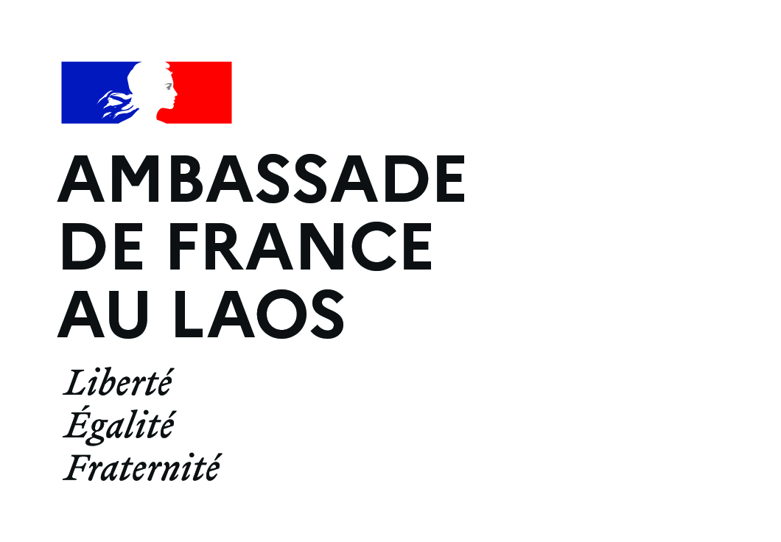

PISCCA 2020-2021
Call for Civil Society’s Innovative Projects

APPLICATION FORM

Deadline to submit proposals: 28/02/2021
Selection of the projects: March 2021

Please read the PISCCA call for project (click here to download) & Frequently asked questions (click here to download) before filling in the application form

HOW TO APPLY
Complete the application form below, the document should not exceed 15 pages and should be typed in English.
In addition to the completed form, please join to the application the following documents:
☐ Certification of registration or proof of submission to the Ministry of Home Affairs and its translation in English;
☐ Last annual report (in English);
☐ Any other document in English that the applicant deems useful can be included.

Send the completed application by email no later than 28/02/2021

- PdF format, subject “PISCCA Name of the organization project proposal” to: Piscca.vientiane-amba@diplomatie.gouv.fr .
- Summary of the application (1 page maximum)

- Information on organization

If you are registered in the lao CSO Directory on lao civil society website, you can fill the table using the data already provided on your profile https://www.laocivilsociety.org/

NAME OF ORGANIZATION (to be completed):
Year of establishment
Type of organization
Director
Main coordinator name
Main coordinator contact (telephone and whatsapp)
Office address and contact
Mission
Main goal
Target group(s)
Sector(s): Agriculture / Capacity building / Climate change adaptation / Community Development / Education / Environment / Forestry / Gender / Health / Disabilities / Human Rights / Nutrition / Income generation / Infrastructure / Law / Micro Finance / Nutrition / Renewable energy / Social Protection / Wash / Other (please specify)

Province

- Project description

- What is the title of your project?
- Main goal of your project:
- Total budget of your project (LAK):
- Budget requested (LAK) :
- When do you expect your project to start and when would it end? From MM/YY to MM/YY (maximum 31/03/2022)
- Where will your project be implemented? Please provide the name of province(s), district(s) and village(s)
- Please describe who will be the main beneficiaries of your project and give an estimated number if possible:

Short description of the project (max 70 words):

- Detailed presentation of the project

- Issues addressed and project design

- Problem identification: What are the issues/problems/challenges faced by the target group/communities you work with? What are their needs? Why is it important to address them? Please include statistics/data (maximum 100 words)
- Please describe how this project has been designed. Did you interact with your target beneficiaries, local government, or any other partner? If that is the case, please describe how you consulted them (maximum 50 words)
- How will your project address issues/challenges/problems faced by target beneficiaries mentioned above? How will it improve/change their situation? (maximum 50 words)

- Objectives
Feel free to add objectives up to 5

- Title of objective 1: ________________________
Description: How will this objective help to achieve the main goal of your project?
- Activity 1.1: description and expected result
- Activity 1.2: description and expected result
- Feel free to add activities up to 5

- Title of objective 2: _________________________
Description: How will this objective help to achieve the main goal of your project?
- Activity 2.1: description and expected result
- Activity 2.2: description and expected result
- Feel free to add activities up to 5

- Additional information on project

- Sustainability: Please explain what will remain after the project (maximum 100 words)
- Please describe the potential risks in project implementation and how you will mitigate them (maximum 70 words)
- Cross cutting issues: Please describe how this project will address any thematic priority of the grant/cross cutting issue (youth, gender, innovation, climate change etc.) (maximum 100 words)
- Regarding gender, how would you rate your project according to Development Assistance Committee (DAC) gender policy marker?
☐ Marker 2 “Principal”: means that gender equality is the main objective of your project and is fundamental is its design and expected results. The project would not have been undertaken without this objective.
☐ Marker 1 “Significant” means that gender equality is an important and deliberate objective, but not the principal reason for undertaking your project, often explained as gender equality being mainstreamed in the project.
☐ Marker 0 “Not targeted” means that your project has been screened against the gender marker but has not been found to target gender equality.
- Logframe, timeframe and budget

- Logframe

Problem/issue | Activity | Expected result  (what will be achieved, who will benefit, …) | Target indicator (number of people trained, …) | Source of verification (reports, minute of meeting, survey…)
Objective 1
 | 1.1
 | 1.2
Feel free to add as many objective that you need
Objective 2
 | 2.1
 | 2.2
 | …

- Timeframe

The last month of implementation must be dedicated to collect monitoring & evaluation data and to report writing.

Description of activities | Timeframe (months)
 | 1 | 2 |  | 3 |  | 4 |  | 5 |  | 6 | 7 |  | 8 |  | 9 |  | 10 |  | 11
Objective 1
Activity 1.1
Activity 1.2
Feel free to activities up to 5
Objective 2
Activity 2.1
Activity 2.2
Feel free to add activities up to 5

- Budget
The budget must be drawn up in accordance with the following exchange rate 0,000102€ =1 LAK
- Total budget of the project (LAK):
- Budget requested to PISCCA (LAK):
- Contribution (LAK) from own organization/community (as mentioned in the call for projects, the applicant institution must be able to contribute financially to the project at least 10% on its own resources):
- Co-financing from other donors (if any, precise the donor, time period and currency):

Description | Unit | Cost per unit (LAK) | No. of Units | Total budget (LAK) | PISCCA contribution (LAK) | Total budget (EUR) | PISCCA contribution (EUR)
Human resources/Salaries (max 30%)
Details (position and % of time dedicated to the project)
-
-
Activities
Activity 1.1
Activity 1.2
…
Support/administrative costs
Details:
-
-
Others (Justify)
Details:
-
-

- Project team and implementing partners

- Project team

- Name/position of project coordinator:
- Project team: Projects are implemented by people. Tell us about the people from your organization that are responsible for completion of the project and their roles in project implementation

Name (if already in place) | Position | Role in the project

- Partners

- Please identify your partners and how you will work with them on project implementation and activities

Name of the partner | Type of organization (government at national or local level, civil society organization…) | Role in the project and modalities of the partnership

- Monitoring and evaluation (M&E) and capacity building

- Monitoring and evaluation (maximum 100 words)

- How will you know that your activities are successful? (If possible provide indicators)
- Briefly describe how your organization will monitor progress, record impact and share learning from the project activities
- Who will be in charge of collecting and analyzing data information on project progress/impact?
- Will you conduct a baseline survey and/or final evaluation for this project?

- Capacity building (maximum 70 words)

- Please describe capacity development needs of your organization for this project
- What do you expect to learn from the project?

- Commitment

The applicant hereby declares that all Information on the form is correct and truthful.

Signature of the president and stamp of the organization:

This share will take into account the salaries of your organization’s employees, please precise their position and % of time dedicated to the project. If you are working with short term experts or service provider for specific activities for example training or designing awareness material or tools, this could be mentioned in activities.

